

Cyberster Internship Program

Internship Report
TRACK: BLUE TEAM
NAME: MUHAMMAD RAZA
INSTRUCTOR: ABDULLAH ZIA
ROLL NUMBER: CSI-B1-121
WEEK 3: SURICATA IDS INTEGRATION WITH WAZUH

TABLE OF CONTENTS

Overview 4
Days 15 and 16 — Suricata Installation and Configuration 4
Conceptual Foundations 4
Installation and Network Configuration 5
Day 17 — Suricata Rule Writing 6
Rule Engineering 6
Threat Execution and Alert Verification 8
Days 18 and 19 — Suricata and Wazuh Integration 9
Log Forwarding and Troubleshooting 9
Dashboard Verification 11
Event Correlation Analysis 12
Days 20 and 21 — GeoIP Blocking and Firewall Rules 13
Implementing GeoIP Restrictions 13
Local DNS Sinkholing 15
Security Limitations and Wazuh Visibility 15

Overview
Week 3 transitions the SOC environment from exclusively host-based monitoring to comprehensive network visibility and perimeter defense. While Wazuh is highly effective at tracking file modifications, log anomalies, and authentication attempts, it inherently lacks visibility into raw network traffic. To eliminate this blind spot, Suricata, a high-performance Network Intrusion Detection System (NIDS), was deployed.
The primary objective of this week was to install Suricata, write custom signature-based detection rules for specific threats, forward the network alerts into the central Wazuh Manager, and correlate network attacks with host-level breaches. Finally, active perimeter defense was established by deploying IPSet and IPtables to block malicious traffic originating from foreign geographic regions.

Days 15 and 16 — Suricata Installation and Configuration

Conceptual Foundations
Before deployment, it is crucial to understand Suricata's operating modes and logging mechanisms:
- IDS vs. IPS: Suricata was deployed in Intrusion Detection System (IDS) mode rather than Intrusion Prevention System (IPS) mode. IDS mode passively inspects copies of network traffic and generates alerts without interfering with packets. IPS mode sits inline and drops traffic, which can cause catastrophic self-denial-of-service if a rule is overly aggressive. In a SOC, detection must be mastered before prevention is implemented.
- fast.log vs eve.json: Suricata outputs alerts to two primary files. fast.log provides a simple, human-readable single-line summary of an alert. eve.json outputs rich, structured JSON data containing extensive metadata (HTTP headers, flow data, payloads) designed specifically for ingestion by SIEMs like Wazuh.

Installation and Network Configuration
Suricata was installed onto the Kali Linux VM to directly monitor the interface generating and receiving attack traffic.
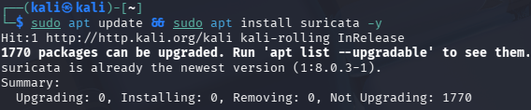
The network interfaces were verified using the ip a command to identify the correct Host-Only adapter.
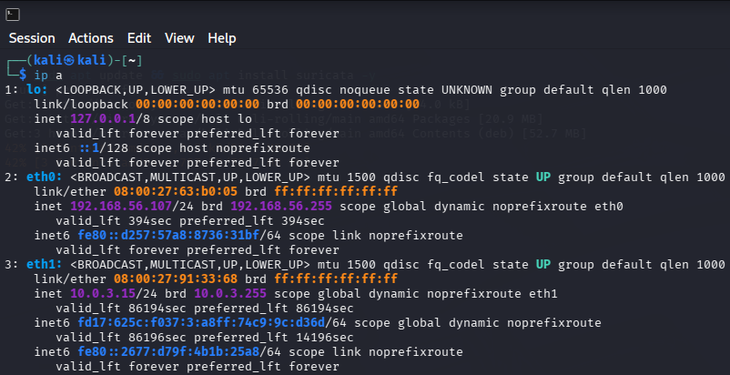
The primary configuration file suricata.yaml was opened to define the network scope and capture interface.
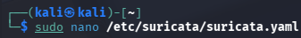
The HOME_NET variable was explicitly configured to monitor the local lab subnet [192.168.56.0/24]. Furthermore, the af-packet capture mechanism was configured to bind to eth0. af-packet utilizes the Linux kernel's high-performance packet capture interface to drop packets directly into Suricata's analysis engine with minimal overhead.
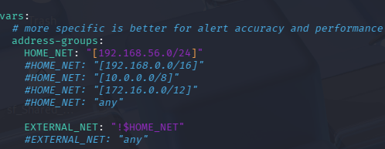
The Suricata service was started and verified to be actively running.
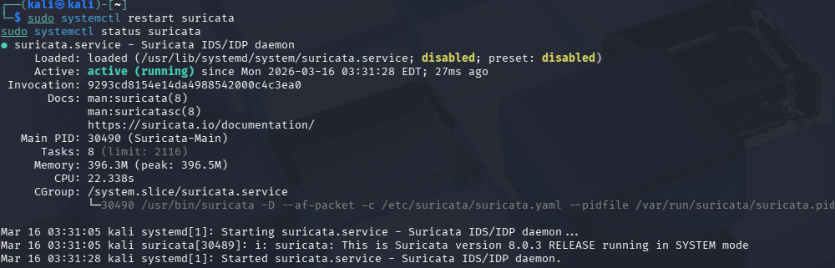
To prepare for rule testing, a continuous read (tail -f) was executed on the fast.log file.
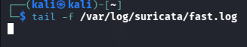

Day 17 — Suricata Rule Writing

Rule Engineering
Suricata utilizes a robust syntax to perform both signature-based detection (matching explicit byte sequences) and anomaly-based detection (identifying behavioral deviations like floods or scans). The suricata.yaml file was modified to explicitly load custom signatures from a local rules file.
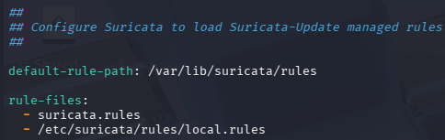
The local rules file was opened to author three custom detection signatures.
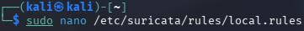
The rules were engineered with unique SIDs (100000X) to prevent conflicts with the community ruleset.

Custom Rules Breakdown
Rule Type | Threat Scenario | Rule Logic & Thresholds
ICMP Flood | Detects Denial of Service (DoS) attempts or aggressive network sweeps using rapid ping requests. | The rule inspects icmp traffic looking for itype:8 (Echo Request). A threshold parameter is essential here; without it, every legitimate ping would trigger an alert. The rule fires only if a high volume of packets from a single source exceeds the defined limit within a brief timeframe.
Nmap SYN Scan | Detects reconnaissance activity where an attacker maps open ports without fully completing the TCP handshake. | The rule looks for tcp packets sent to any port containing exclusively the SYN flag (flags:S). It is classified as attempted-recon.
Malicious HTTP | Detects Directory Traversal exploits (../../../etc/passwd) or unauthorized command-line web requests. | The rule specifically filters for the GET method and inspects the HTTP headers. It searches for content:"Wget" within the http.user_agent field, classifying it as a web-application-attack.
Following rule creation, Suricata's configuration test flag (-T) was executed to parse the custom rules and verify there were zero syntax errors.
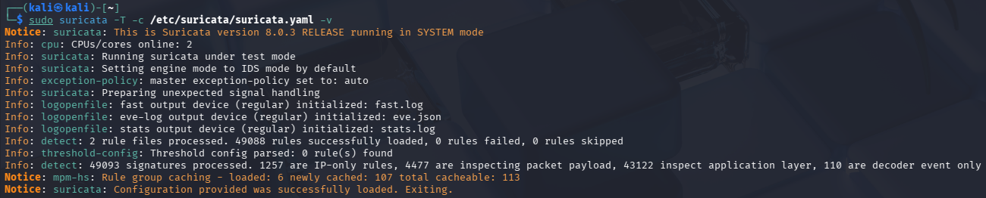

Threat Execution and Alert Verification
To validate the rules, Suricata was started manually in the foreground, binding to both the loopback (lo) and primary (eth0) interfaces to capture local exploit attempts.
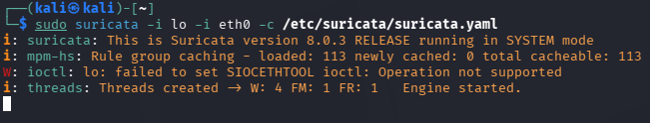
A dummy Python HTTP server was spun up to ensure web exploit payloads would successfully traverse the network rather than immediately dropping.
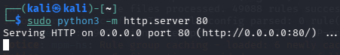
The three attacks were systematically launched against the target environment.
Attack 1: ICMP Flood (ping -f)
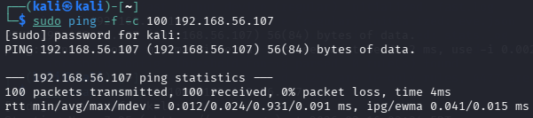
Attack 2: Nmap SYN Scan (nmap -sS)
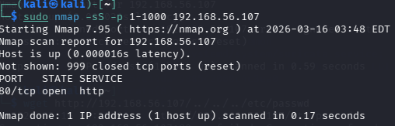
Attack 3: HTTP Exploit / Directory Traversal (wget)
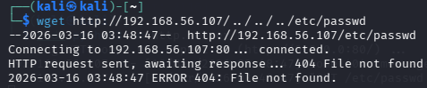
The fast.log output was queried to confirm the successful detection of all three threat scenarios.
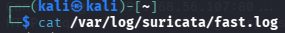
The ICMP Flood generated high-volume alerts grouped by the threshold limit.
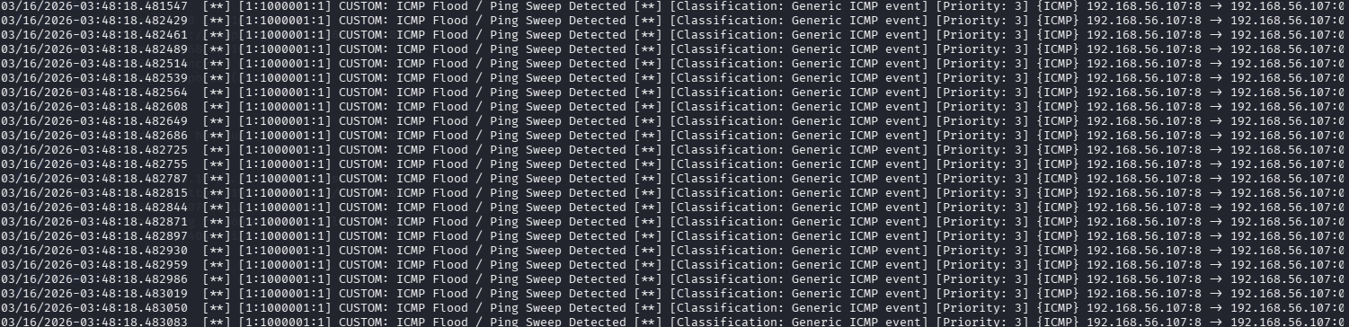
The Nmap scan correctly triggered a barrage of attempted reconnaissance alerts.
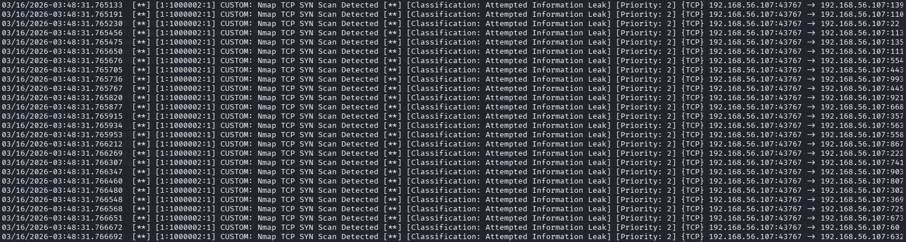
The Malicious HTTP rule successfully caught the wget web application attack.

Days 18 and 19 — Suricata and Wazuh Integration

Log Forwarding and Troubleshooting
To unify network and host logs, the Wazuh agent on the Kali VM required configuration to read Suricata's structured JSON output. The agent configuration file was modified.
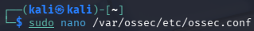
A <localfile> block was appended to /var/ossec/etc/ossec.conf. Crucially, the <log_format> was explicitly defined as json. If left as default (syslog), Wazuh would fail to map the parsed fields, breaking dashboard functionality.
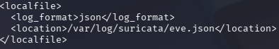
The Wazuh agent was restarted to apply the new log ingestion pipeline.
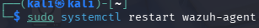
To verify Suricata was outputting properly formatted data to the pipeline source, the eve.json file was queried.
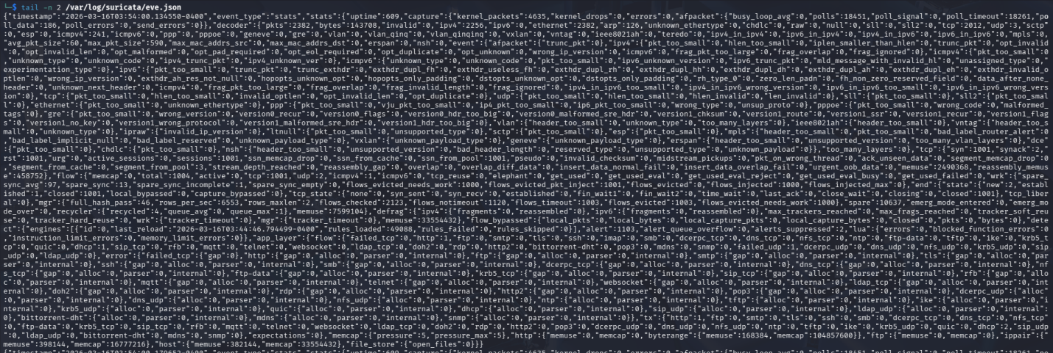
The raw JSON payload for the ICMP flood confirmed proper metadata generation.
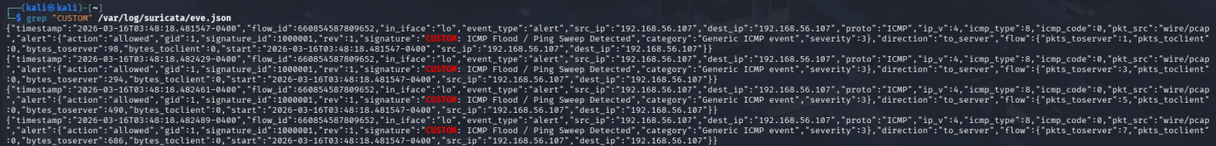
The raw JSON payload for the Nmap scan successfully captured the flow data.
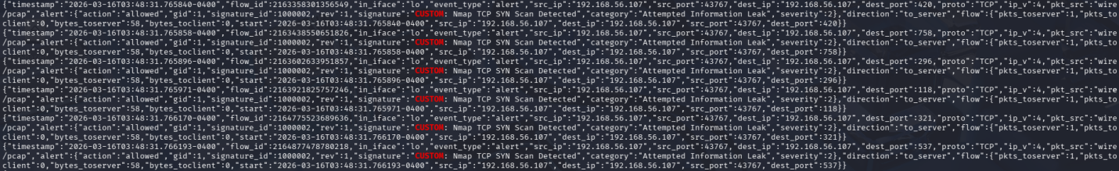
A specific HTTP exploit JSON object was extracted for debugging purposes.
Pipeline Troubleshooting: Initially, the alerts failed to appear in the Wazuh dashboard. The wazuh-logtest utility was utilized to simulate the Manager's decoding engine. An initial user error occurred by pasting the literal grep command into the utility, causing a Phase 2 decoding failure.
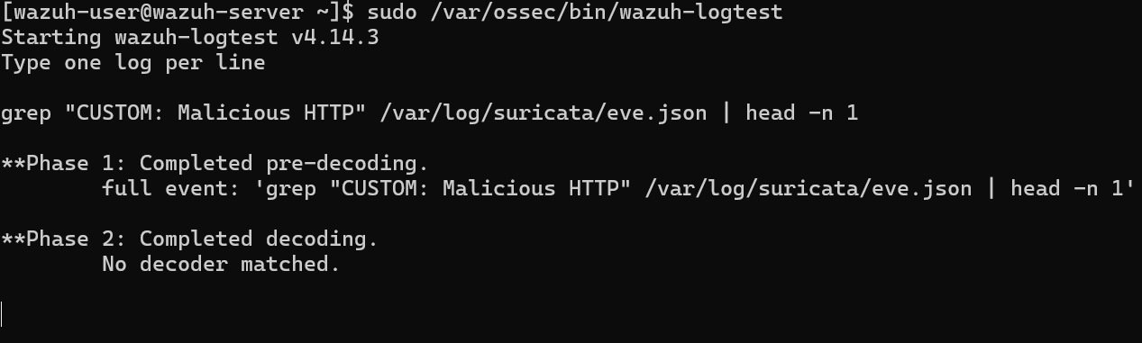
Upon pasting the raw JSON payload, the Suricata decoder successfully parsed the JSON strings in Phase 2.
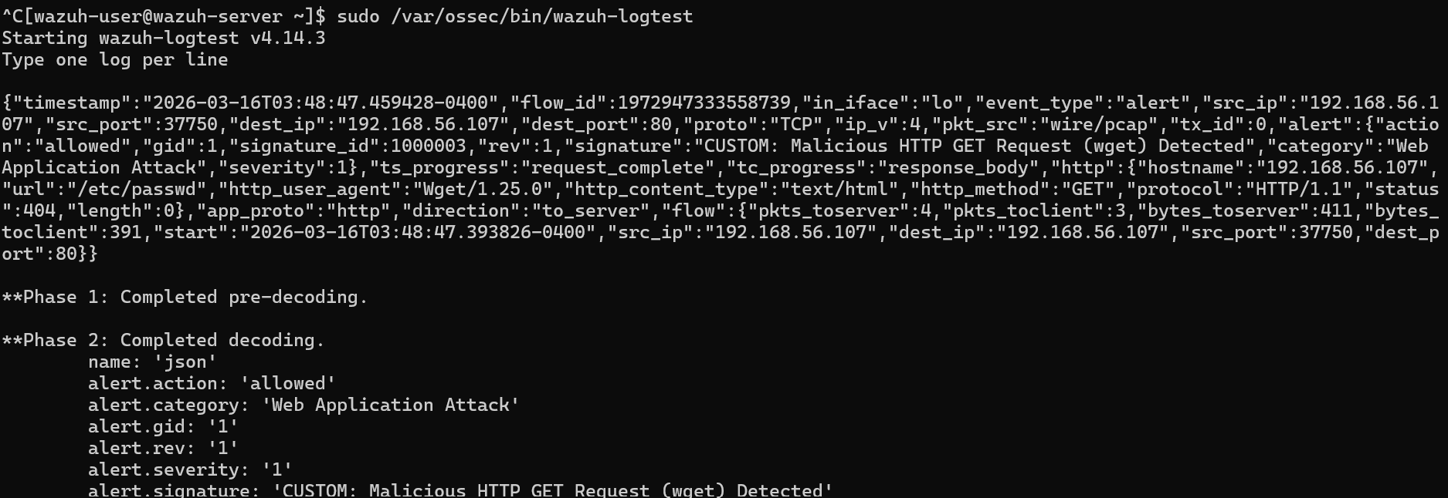
Phase 3 filtering revealed the root cause: The default Wazuh rule for Suricata (86601) assigns a level: 3 priority to these events. By default, the Wazuh dashboard only surfaces alerts of Level 4 or higher, burying the network detections as informational background noise.
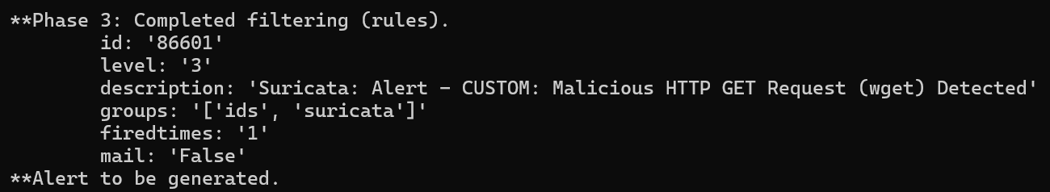
To rectify this, a local rule override was authored on the Wazuh Manager.
Rule 100050 was created to catch any log matching the Suricata base rule (if_sid: 86601) that contained the string "CUSTOM", automatically escalating it to a critical Level 10.
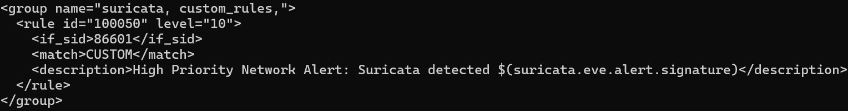

Dashboard Verification
Following the Manager restart, the attacks were relaunched. The custom rules successfully bypassed the filtering threshold and populated the Security Events dashboard with fully parsed JSON fields.
Dashboard View: ICMP Flood
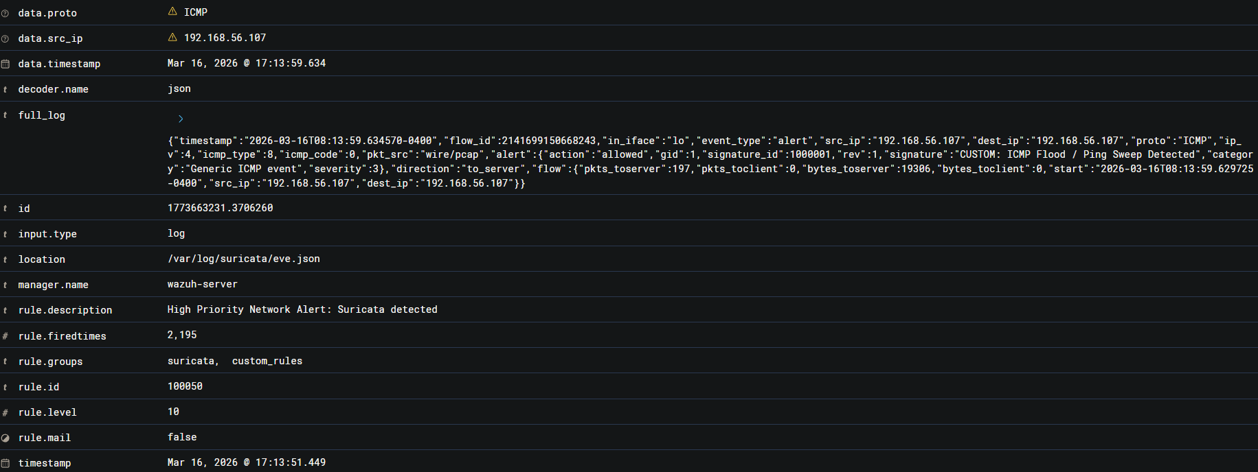
Dashboard View: Malicious HTTP Request
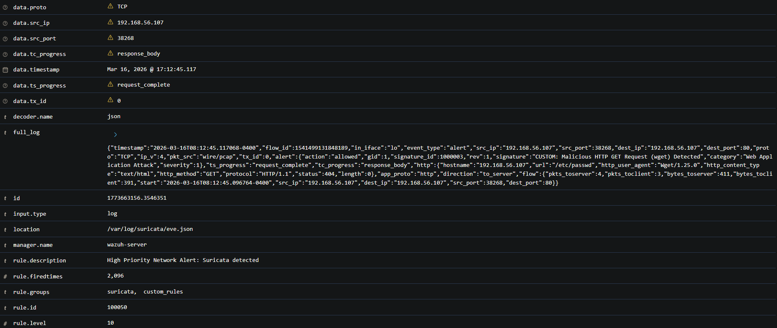

Dashboard View: Nmap TCP SYN Scan
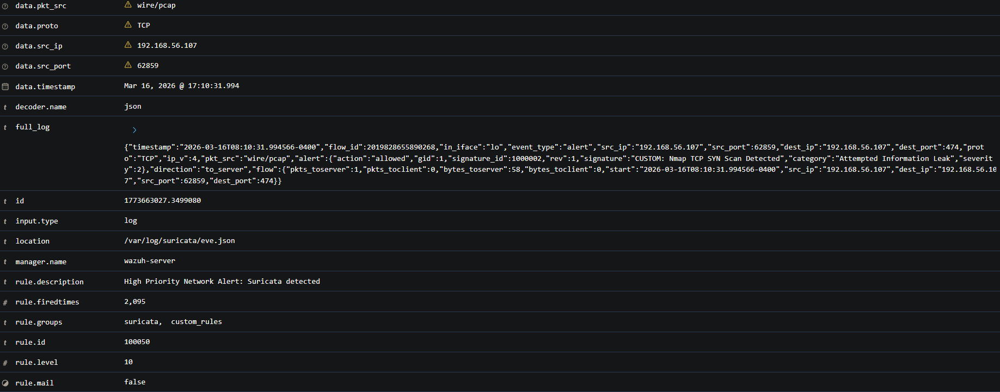

Event Correlation Analysis
The true power of integrating a NIDS into a SIEM is the ability to correlate an attack across both the network and the host layers to build a complete narrative.
To demonstrate this, an Nmap scan was launched against the Ubuntu Server (192.168.56.104) to trigger a network reconnaissance alert.
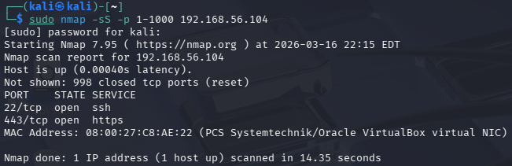
Immediately following the scan, an SSH session was established with the target server, and a malicious script (/etc/malicious_backdoor.sh) was created to trigger a Wazuh File Integrity Monitoring (FIM) alert.
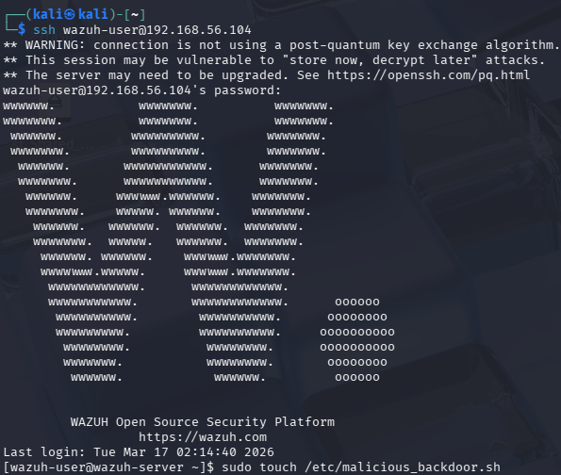
The Nmap network event correctly logged the targeted behavior.
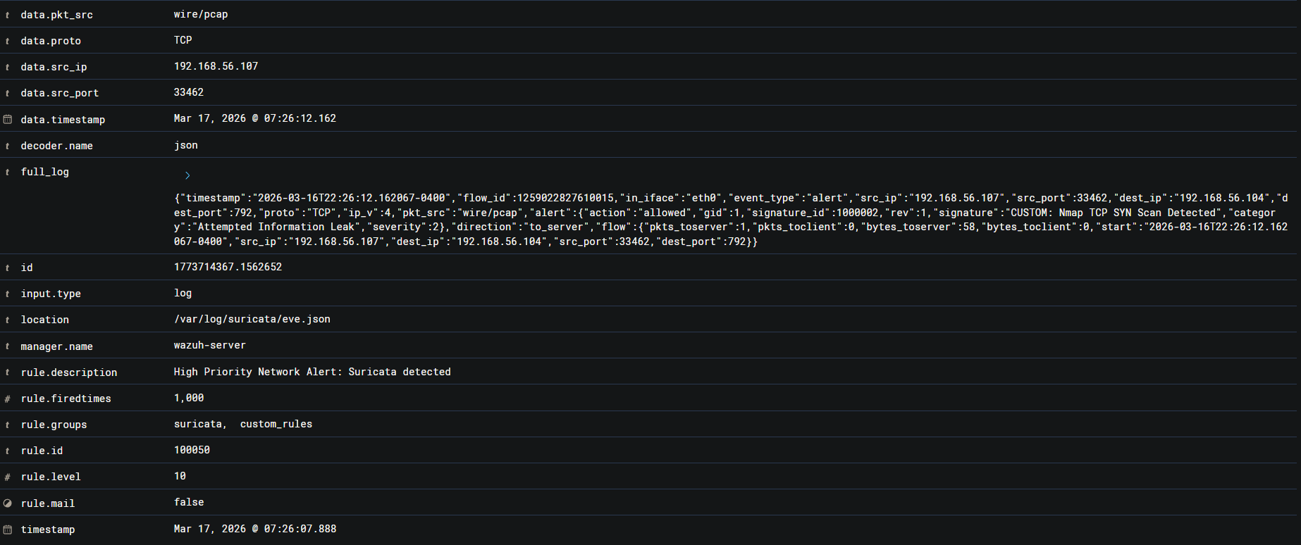
By filtering the Threat Hunting dashboard by the Ubuntu Server, both events were viewed simultaneously on a unified timeline.
Correlation Conclusion: On its own, the Suricata alert only indicates reconnaissance; it does not confirm a breach. On its own, the Wazuh FIM alert shows a system change, but doesn't explain how the attacker identified the target. By correlating these alerts in a single pane of glass, a complete attack narrative emerges: The attacker mapped the server's open ports via a SYN scan, successfully authenticated, and established persistence by dropping a payload into a sensitive directory. Without both tools, the SOC would operate with a critical blind spot.

Days 20 and 21 — GeoIP Blocking and Firewall Rules
The final phase shifted from active detection to perimeter defense. GeoIP blocking was implemented to universally drop traffic originating from specific geographic regions that hold no legitimate business case for accessing the network.

Implementing GeoIP Restrictions
The required kernel-level tools (iptables, ipset, and xtables-addons-common) were installed.
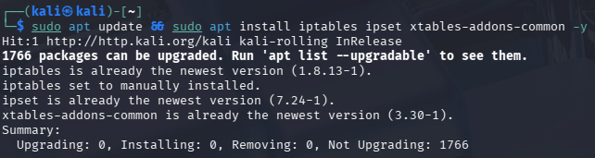

A raw zone file containing over 8,000 subnets allocated to China (cn.zone) was downloaded from ipdeny.com.
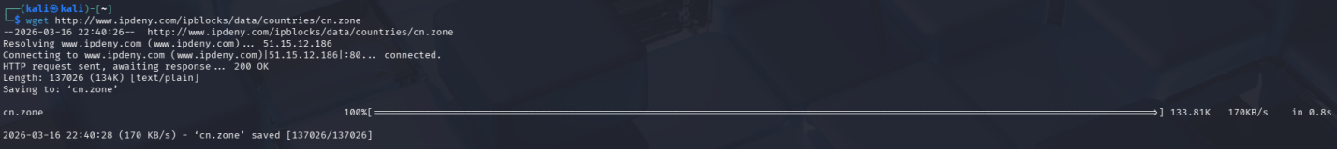
A dedicated ipset bucket (block_cn) was initialized in the kernel to hold the target addresses.
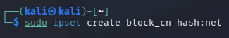
A for loop was executed to iterate through the text file and push all 8,000+ CIDR blocks into the ipset. (Note: In a production environment, ipset restore is preferred to bypass the significant time delay of iterative loop injection).
With the bucket populated, a single iptables rule was injected at the top of the INPUT chain, instructing the firewall to actively DROP any packets originating from a source IP found within the block_cn set.
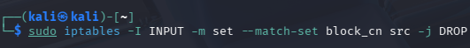
Verification of the firewall ruleset confirmed the drop logic was correctly bound to the hash:net list.
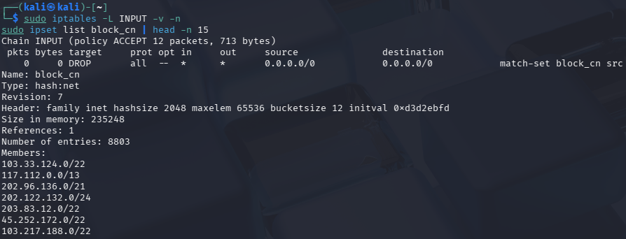

Local DNS Sinkholing
To compliment inbound blocking, outbound DNS restrictions were configured via the /etc/hosts file.
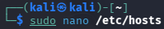
Simulated malicious domains were routed directly to the 127.0.0.1 loopback address, effectively creating a local DNS sinkhole.
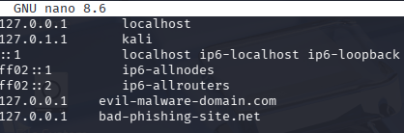
Testing via curl confirmed that requests to the flagged domains were instantly hijacked and met with a Connection refused error, preventing the machine from reaching the actual internet endpoints.
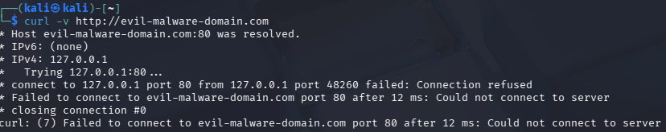

Security Limitations and Wazuh Visibility
Concept | Analysis
IPSet vs. IPtables | ipset is utilized because it stores thousands of IP ranges in a highly optimized hash map. If iptables had to read 8,000 individual rules line-by-line for every packet, network performance would collapse. ipset allows the firewall to check one single rule instantly.
DROP vs. REJECT | The firewall was configured to DROP traffic, which silently discards the packet, forcing the attacker's scanner to time out and wasting their resources. A REJECT rule actively sends an ICMP "Connection Refused" packet back, which confirms to the attacker that the host is alive and actively blocking them.
Wazuh Visibility | Wazuh did not generate an alert for this blocked traffic. A standard iptables -j DROP rule discards the packet silently without writing an entry to syslog or kern.log. Because no local log is generated, the Wazuh agent has nothing to report. To achieve SIEM visibility, a dedicated -j LOG rule must be placed directly above the DROP rule.
GeoIP Limitations & Persistence | GeoIP blocking is merely a layer of friction. Sophisticated threat actors easily bypass it by routing attacks through compromised infrastructure or VPNs located in permitted countries. Furthermore, these iptables and ipset rules reside in volatile memory; they will vanish upon system reboot unless explicitly saved and restored using a firewall manager like ufw or iptables-persistent.

End of Week 3 Report

